CT2106 Assignment 3

Michael Mc Curtin

ID: 21459584

# Project Description

The project represents a hierarchy of the **Animal** Kingdom.

Animals are either categorised as **Birds** or **Fish** based on physical characteristics (e.g. whether they have feathers or gills) and based on movement (whether they can swim or can fly).

The bird species **Canary** and **Ostrich**, and the fish species **Shark** and **Trout** further descend from this categorisation.

The **AnimalTest** class creates several named animals of each type. It then goes on to run comparisons between them to see if they are logically equivalent to one another based on their characteristics.

# AnimalTest class

public class AnimalTest {  
 public static void main(String[] args) {  
 *test1*();  
 *test2*();  
 }  
 public static void test1() {  
  
 System.*out*.println("--------TEST 1---------\n");  
  
 // create array of 4 animals of the 4 different types  
  
 Animal[] animals = new Animal[4];  
  
 animals[0] = new Canary("Aretha");  
 animals[1] = new Ostrich("Stevie");  
 animals[2] = new Shark("Marvin");  
 animals[3] = new Trout("Ray");  
  
 // print out animal toString information  
  
 for (int i = 0; i < animals.length; i++) {  
 System.*out*.println(animals[i]);  
 }  
 }

public static void test2() {  
  
 System.*out*.println("--------TEST 2---------\n");  
  
 // create array of 8 animals of the 4 different types  
  
  
 Animal[] animals = new Animal[8];  
  
  
 animals[0] = new Canary("Lucas");  
 animals[1] = new Canary("Steve");  
 animals[2] = new Ostrich("Dimitri");  
 animals[3] = new Ostrich("Mike");  
 animals[4] = new Shark("Thomas");  
 animals[5] = new Shark("Guy");  
 animals[6] = new Trout("Sasha");  
 animals[7] = new Trout("John");  
  
  
 // print out animal toString information  
  
  
 for (int i = 0; i < animals.length; i++) {  
 System.*out*.println(animals[i]);  
 }  
  
  
 // print out whether each animal is equal to the next animal  
  
 for (int i = 0, j = 1; j < animals.length; i++) {  
 System.*out*.println(String.*format*("\nAnimal at index %d equals Animal at index %d ?\n", i, j));  
 System.*out*.println(animals[i].equals(animals[j]));  
 j++;  
 }  
  
 }  
}

# AnimalTest test1 Output

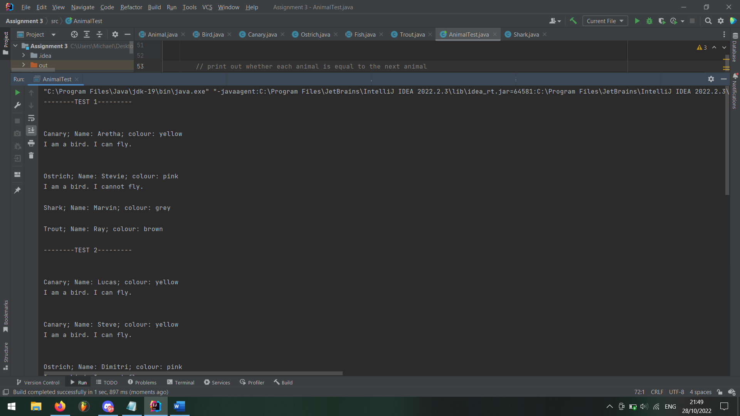

# AnimalTest test2 Output

# Bird class

public abstract class Bird extends Animal  
{  
 //instance variables (fields)  
 boolean hasFeathers;  
 boolean hasWings;  
 boolean flies;  
  
 */**  
 * Constructor for objects of class Bird  
 */* public Bird()  
 {  
 super(); //calls the constructor of its superclass - Animal  
 colour = "black"; //overrides the value of colour inherited from Animal  
 hasFeathers = true; //all the subclasses of Fish inherit this property and value  
 hasWings = true; //all the subclasses of Fish inherit this property and value  
 flies = true; //all the subclasses of Fish inherit this property and value  
 }  
  
 */**  
 * move method overrides the move method  
 * inherited from superclass Animal  
 */* @Override  
 public void move(int distance){  
  
 // not all birds fly so change movement message based on this  
  
 if (flies = true) {  
 System.*out*.printf("I fly %d metres \n", distance);  
 }  
 else {  
 System.out.printf("I run %d metres \n", distance);  
 }  
  
 }

*/**  
 * toString method overrides the toString method  
 * inherited from superclass Animal  
 */* @Override  
 public String toString(){  
  
 // say whether the bird can fly or not  
  
 String condition;  
  
 if (this.flies){  
 condition = "can";  
 }  
  
 else {  
 condition = "cannot";  
 }  
 String strng = String.format("I am a bird. I %s fly.\n", condition);  
 return strng;  
 }  
  
  
 */**  
 * equals method overrides the equals method  
 * inherited from superclass Animal  
 */* @Override  
 public boolean equals(Object o) {  
 if (this == o) return true; // check if object is this object  
 if (!(o instanceof Bird bird)) return false; // check if object is a Bird  
 if (!super.equals(o)) return false; // check if object is an Animal  
 return hasFeathers == bird.hasFeathers && hasWings == bird.hasWings && flies == bird.flies;  
 }  
  
 */**  
 * sing method  
 * All subclasses inherit this method  
 */* public void sing(){  
 System.out.println("tra la la");  
 }  
   
 */**  
 * 'getter' method for the hasWings field  
 * All subclasses inherit this method  
 */* public boolean hasWings(){  
 return hasWings;  
 }  
   
 */**  
 * 'getter' method for the hasFeathers field  
 * All subclasses inherit this method  
 */* public boolean hasFeathers(){  
 return hasFeathers;  
 }  
}

# Canary class

import java.util.Objects;  
  
public class Canary extends Bird  
{  
   
 String name; // the name of this Canary  
  
 */**  
 * Constructor for objects of class Canary  
 */* public Canary(String name)  
 {  
 super(); // call the constructor of the superclass Bird  
 this.name = name;  
 colour = "yellow"; // this overrides the value inherited from Bird  
   
 }  
   
 */**  
 * Sing method overrides the sing method  
 * inherited from superclass Bird  
 */* @Override // good programming practice to use @Override to denote overridden methods  
 public void sing(){  
 System.out.println("tweet tweet tweet");  
 }  
  
 */**  
 * toString method overrides the toString method  
 * inherited from superclass Bird  
 */* @Override  
 public String toString(){  
 String strng;  
 strng = String.format("\nCanary; Name: %s; colour: %s\n", name, colour);  
 strng += super.toString();  
 return strng;  
 }

*/**  
 * equals method defines how equality is defined between   
 * the instances of the Canary class  
 * param Object  
 * return true or false depending on whether the input object is   
 * equal to this Canary object  
 */* @Override  
 public boolean equals(Object o) {  
 if (this == o) return true; // check if object is this object  
 if (!(o instanceof Canary canary)) return false; // check if object is a Canary  
 if (!super.equals(o)) return false; // check if object is a Bird  
 return Objects.equals(getColour(), canary.getColour());  
 }  
  
}

# Ostrich class

public class Ostrich extends Bird  
{  
  
 String name; // the name of this Ostrich  
 String legs; // leg information  
  
 String height;  
  
 */**  
 * Constructor for objects of class Ostrich  
 */* public Ostrich(String name)  
 {  
 super(); // call the constructor of the superclass Bird  
 this.name = name;  
 colour = "pink"; // this overrides the value inherited from Bird  
 flies = false;  
 legs = "thin and long";  
 height = "tall";  
 }  
  
 */**  
 * toString method overrides the toString method  
 * inherited from superclass Bird  
 */* @Override  
 public String toString(){  
 String strng;  
  
 strng = String.format("\nOstrich; Name: %s; colour: %s\n", name, colour);  
 strng += super.toString();  
 return strng;  
 }  
  
 */**  
 * equals method defines how equality is defined between  
 * the instances of the Ostrich class  
 * param Object  
 * return true or false depending on whether the input object is  
 * equal to this Ostrich object  
 */* @Override  
 public boolean equals(Object o) {  
 if (this == o) return true; // check if object is this object  
 if (!(o instanceof Ostrich ostrich)) return false; // check if object is an Ostrich  
 if (!super.equals(o)) return false; // check if object is a Bird  
 return legs.equals(ostrich.legs) && height.equals(ostrich.height);  
 }  
  
}

# Fish class

import java.util.Objects;  
  
public abstract class Fish extends Animal  
{  
 //instance variables (fields)  
 boolean hasFins;  
 boolean hasGills;  
 boolean swims;  
  
 boolean dangerous;  
 boolean edible;  
  
 */**  
 * Constructor for objects of class Fish  
 */* public Fish()  
 {  
 super(); //calls the constructor of its superclass - Animal  
 colour = "blue"; //sets the value of colour inherited from Animal  
 hasFins = true; //all the subclasses of Fish inherit this property and value  
 hasGills = true; //all the subclasses of Fish inherit this property and value  
 swims = true; //all the subclasses of Fish inherit this property and value  
 edible = false;  
 dangerous = false;  
 }  
  
 */**  
 * move method overrides the move method  
 * inherited from superclass Animal  
 */* @Override // good programming practice to use @Override to denote overridden methods  
 public void move(int distance){  
 System.out.printf("I swim %d metres \n", distance);  
 }  
  
 */**  
 * bite method that all fish have  
 */* public void bite(){  
  
 // fish will only cause harm with its bite if it is dangerous  
  
 if (dangerous) {  
 System.out.println("nomnomnom");  
 }  
  
 else {  
 System.out.println("slurp slurp slurp");  
  
 }  
 }

*/**  
 * equals method defines how equality is defined between  
 * the instances of the Fish class  
 * param Object  
 * return true or false depending on whether the input object is  
 * equal to this Fish object  
 */* @Override  
 public boolean equals(Object o) {  
 if (this == o) return true; // check if object is this object  
 if (!(o instanceof Fish fish)) return false; // check if object is a Fish  
 if (!super.equals(o)) return false; // check if object is an Animal  
 return hasFins == fish.hasFins && hasGills == fish.hasGills && swims == fish.swims;  
 }  
  
 */**  
 * 'getter' method for the hasGills field  
 */* public boolean hasGills(){  
 return hasGills;  
 }  
  
 */**  
 * 'getter' method for the hasFins field  
 */* public boolean hasFins(){  
 return hasFins;  
 }  
}

# Shark class

import java.util.Objects;  
  
public class Shark extends Fish  
{  
  
 String name; // the name of this Shark  
 Boolean dangerous;  
  
 */**  
 * Constructor for objects of class Ostrich  
 */* public Shark(String name)  
 {  
 super(); // call the constructor of the superclass Bird  
 this.name = name;  
 dangerous = true;  
 colour = "grey";  
 }  
  
 */**  
 * bite method overrides the bite method  
 * inherited from superclass Fish  
 */* @Override  
 public void bite(){  
 System.out.println("Shark bite! -90 HP");  
 }  
  
 */**  
 * toString method overrides the toString method  
 * inherited from superclass Fish  
 */* @Override  
 public String toString(){  
 String strng = String.format("Shark; Name: %s; colour: %s\n", name, colour);  
 return strng;  
 }

*/**  
 * equals method defines how equality is defined between  
 * the instances of the Shark class  
 * param Object  
 * return true or false depending on whether the input object is  
 * equal to this Shark object  
 */* @Override  
 public boolean equals(Object o) {  
 if (this == o) return true; // check if object is this object  
 if (!(o instanceof Shark shark)) return false; // check if object is a Shark  
 if (!super.equals(o)) return false; // check if object is a Fish  
 return dangerous.equals(shark.dangerous) && getColour().equals(shark.getColour());  
 }  
  
}

# Trout class

public class Trout extends Fish  
{  
  
 String name; // the name of this Shark  
 Boolean hasSpikes;  
 Boolean swimsUpriver;  
  
 */**  
 * Constructor for objects of class Ostrich  
 */* public Trout(String name) {  
 super(); // call the constructor of the superclass Bird  
 this.name = name;  
 this.colour = "brown";  
 edible = true;  
 hasSpikes = true;  
 }  
  
 */**  
 * toString method overrides the toString method  
 * inherited from superclass Fish  
 */* @Override  
 public String toString(){  
 String strng = String.format("Trout; Name: %s; colour: %s\n", name, colour);  
 return strng;  
 }  
  
 @Override // good programming practice to use @Override to denote overridden methods  
 public void move(int distance){  
  
 System.*out*.println(String.*format*("I swim %d metres upriver to lay eggs.\n", distance));  
 }  
  
  
 */**  
 * equals method defines how equality is defined between  
 * the instances of the Trout class  
 * param Object  
 * return true or false depending on whether the input object is  
 * equal to this Trout object  
 */* @Override  
 public boolean equals(Object o) {  
 if (this == o) return true; // check if object is this object  
 if (!(o instanceof Trout trout)) return false; // check if object is a Trout  
 if (!super.equals(o)) return false; // check if object is a Fish  
 return hasSpikes.equals(trout.hasSpikes) && edible == trout.edible && getColour().equals(trout.getColour());  
 }  
  
}

# Code Explanation

I found that the easiest way to implement condition 1(c) was to make the ToString method of the Bird class to explain whether the bird could fly or not. I then called Bird’s ToString method in each sub-class’s ToString method and concatenated the strings.

Ostrich’s ToString method will therefore become

*Ostrich; Name:* [name]*; colour: pink*

*I am a bird. I cannot fly.*